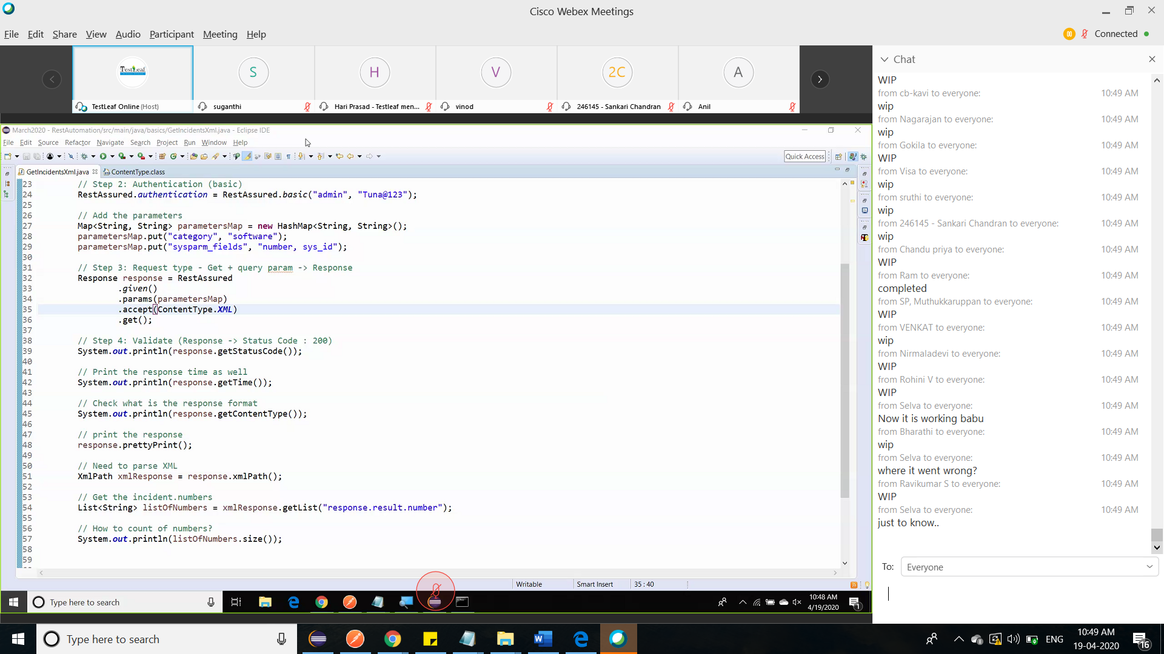

// Step 1: Get the URL / Endpoint for the services RestAssured.baseURI = "https://dev49243.service-now.com/api/now/table/incident"; // Step 2: Authentication (basic) RestAssured.authentication = RestAssured.basic("admin", "Tuna@123"); // Step 3: Request type - Get -> Response Response response = RestAssured.get(); // Step 4: Validate (Response -> Status Code : 200) System.out.println(response.getStatusCode()); // Print the response time as well // Check what is the response format System.out.println(response.getContentType()); // print the response response.prettyPrint();

//

